AI LAB TEST-2
Hall ticket number:2403a53057
Batch number:18
Subgroup G
G.1 — [S20G1] Sum CSV column ignoring bad rows
Context:
CSV exports in urban public transit (metro/bus) have invalid numerics.
Your Task:
Sum 'value' ints; skip invalid rows.
Data & Edge Cases:
id,value
1,10
2,NA
3,7 -> 17.
AI Assistance Expectation:
Use AI to draft csv.DictReader solution and tests.
Constraints & Notes:
Optionally report skipped count.
Sample Input
id,value
1,10
2,NA
3,7
Sample Output
17
Acceptance Criteria: Skips invalid rows; correct total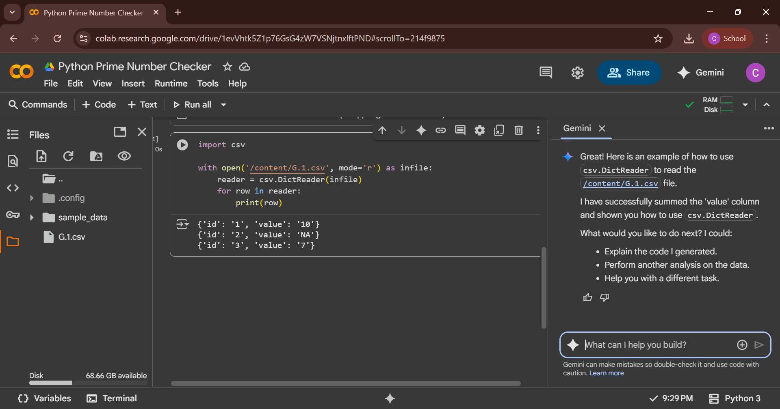
.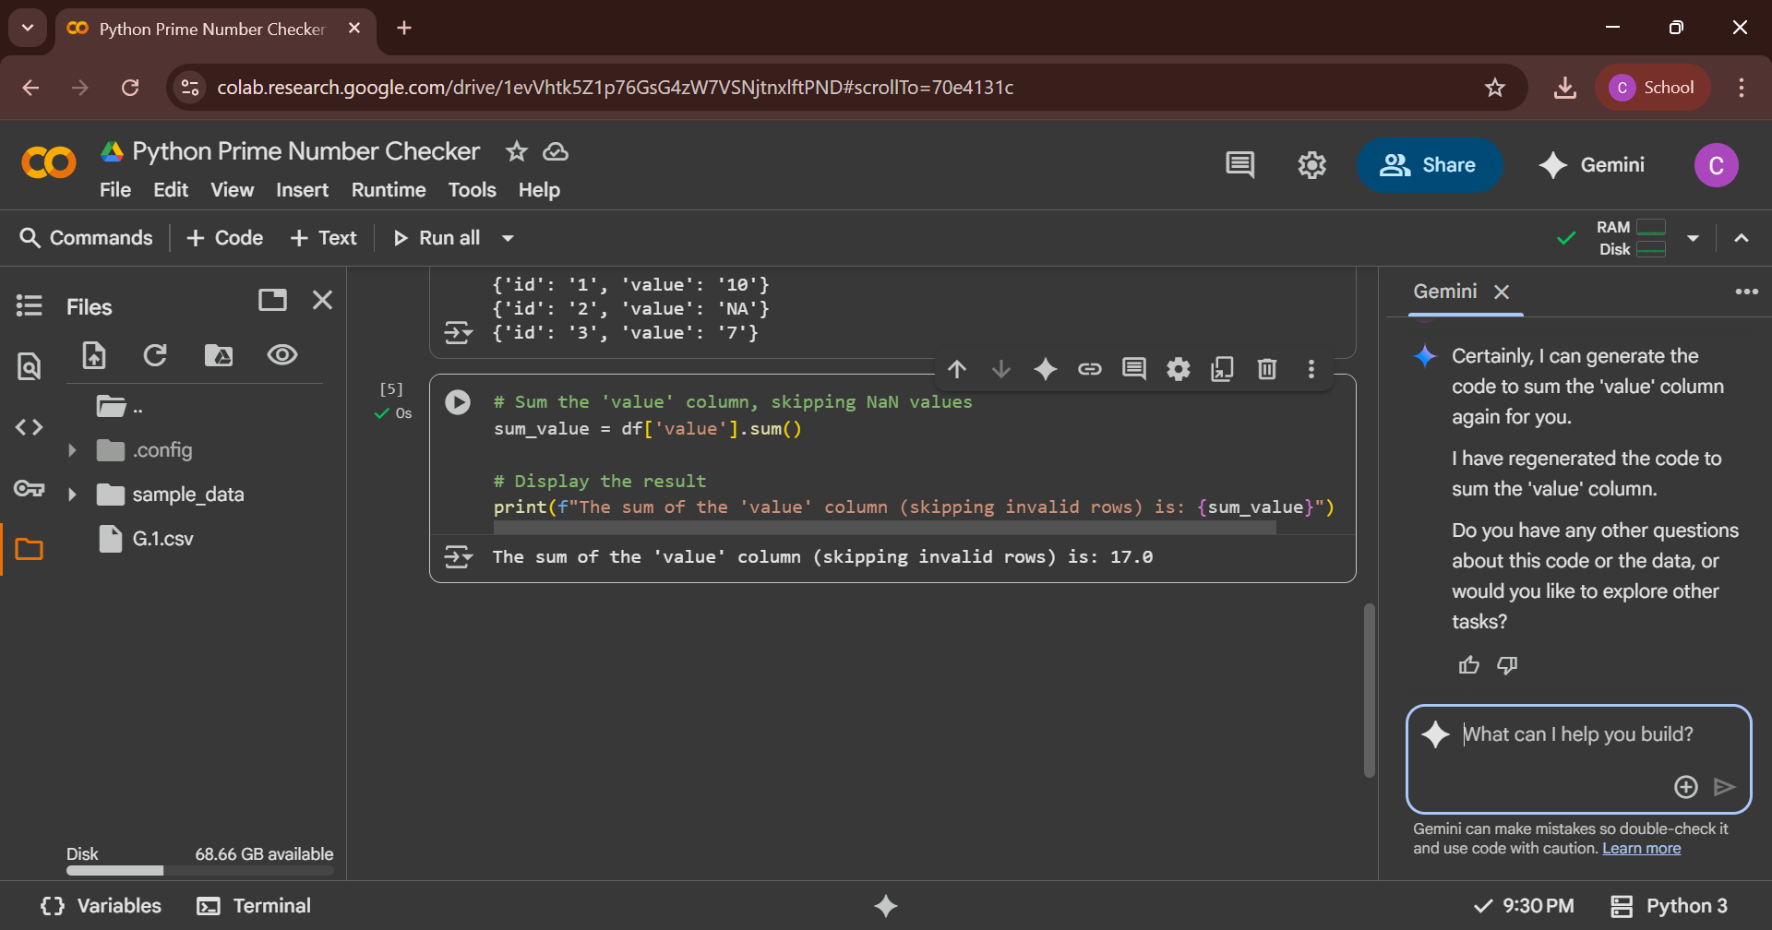
G.2 — [S20G2] Merge two CSVs by id
Context:
Merge two CSVs in urban public transit (metro/bus) by id
Your Task:
Implement inner & left joins without pandas.
Data & Edge Cases:
A:id,price; B:id,qty.
AI Assistance Expectation:
Dict map + loops; add tests.
Constraints & Notes:
Stable order preferred.
Sample Input
id,price
A,10
B,20
---
id,qty
A,2
C,5
Sample Output
inner=[('A',10,2)], left=[('A',10,2),('B',20,None)]
Acceptance Criteria: Correct semantic
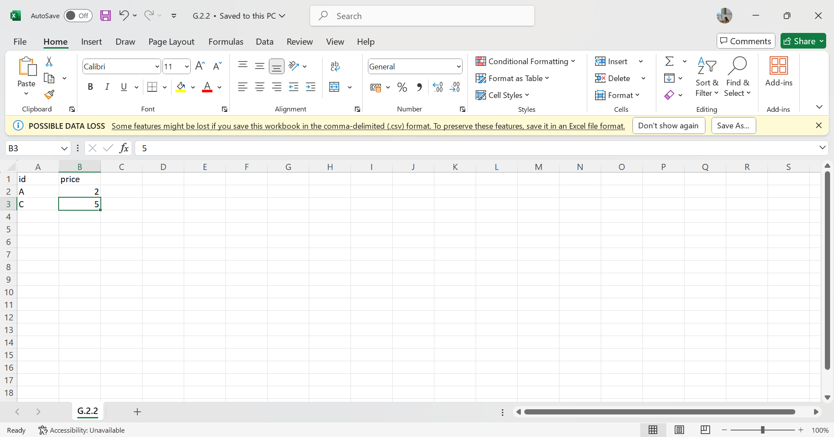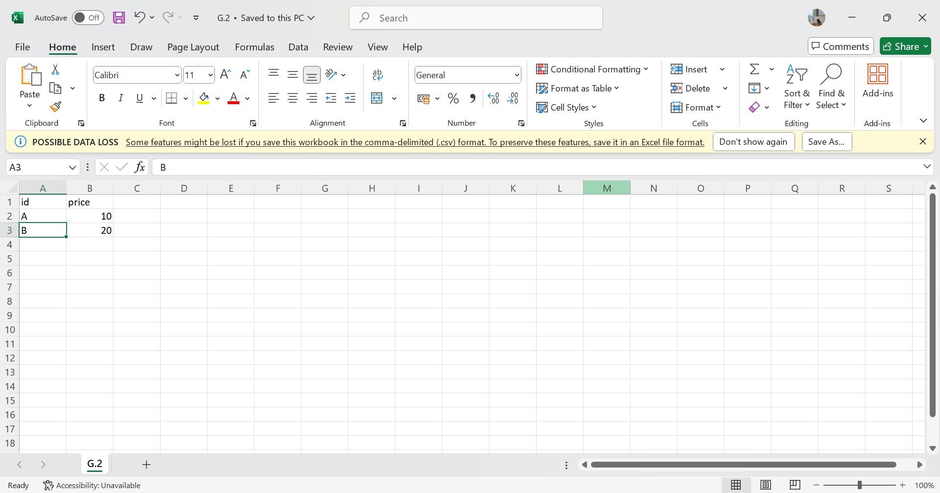
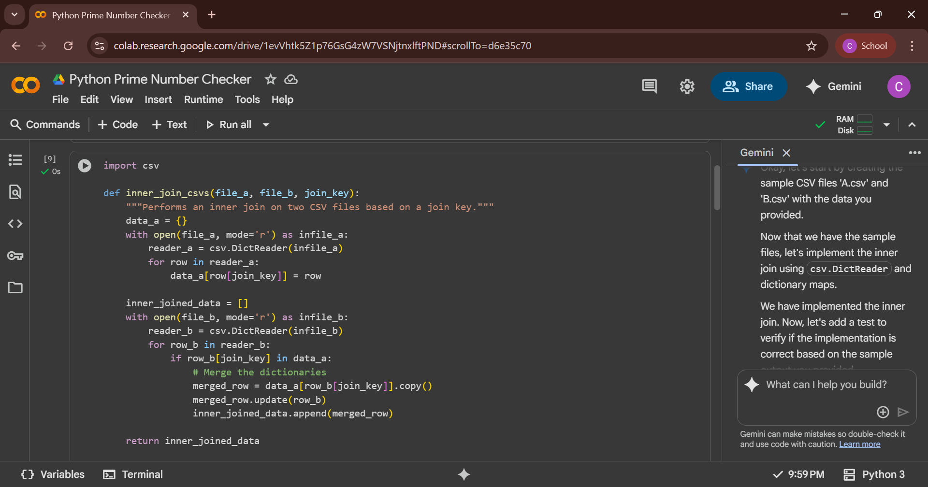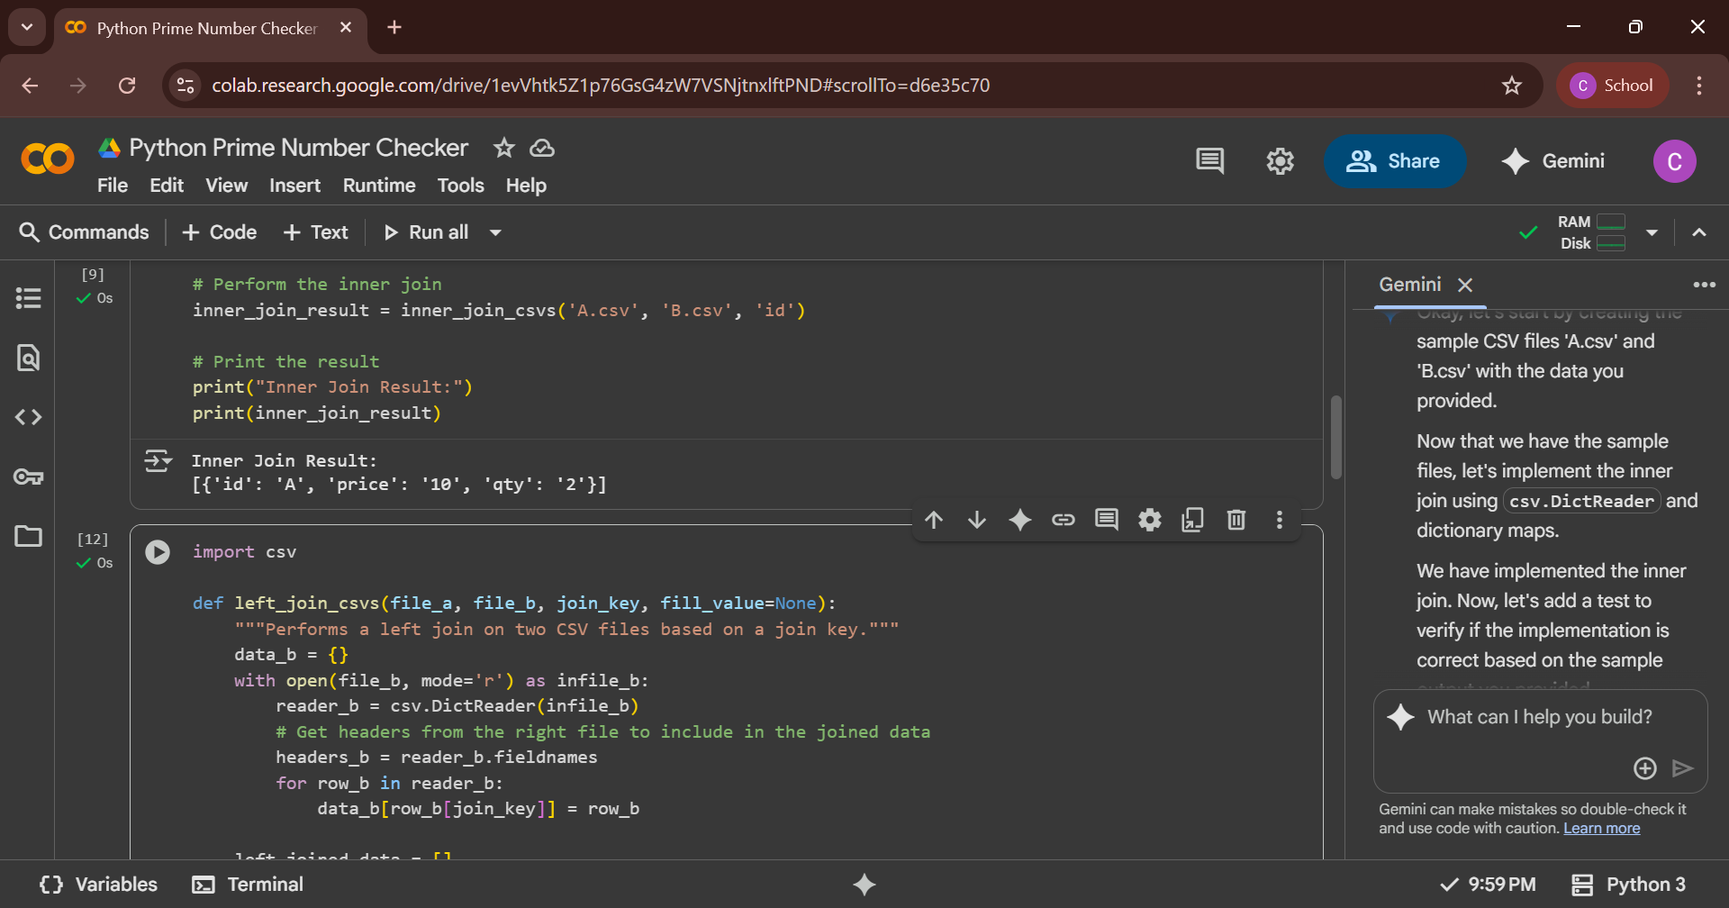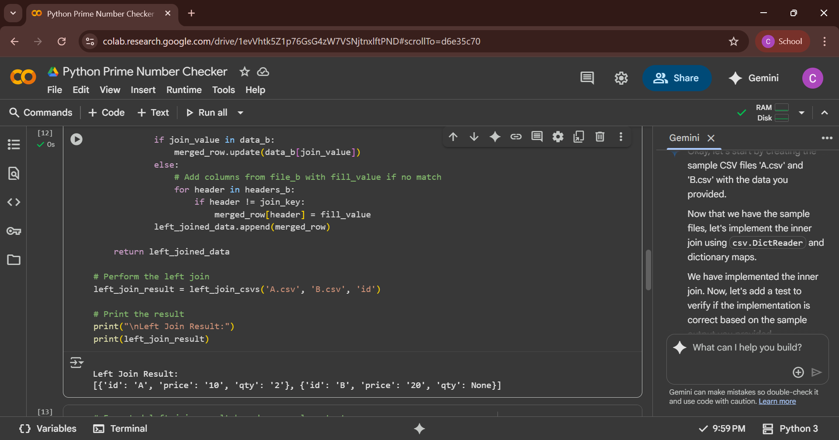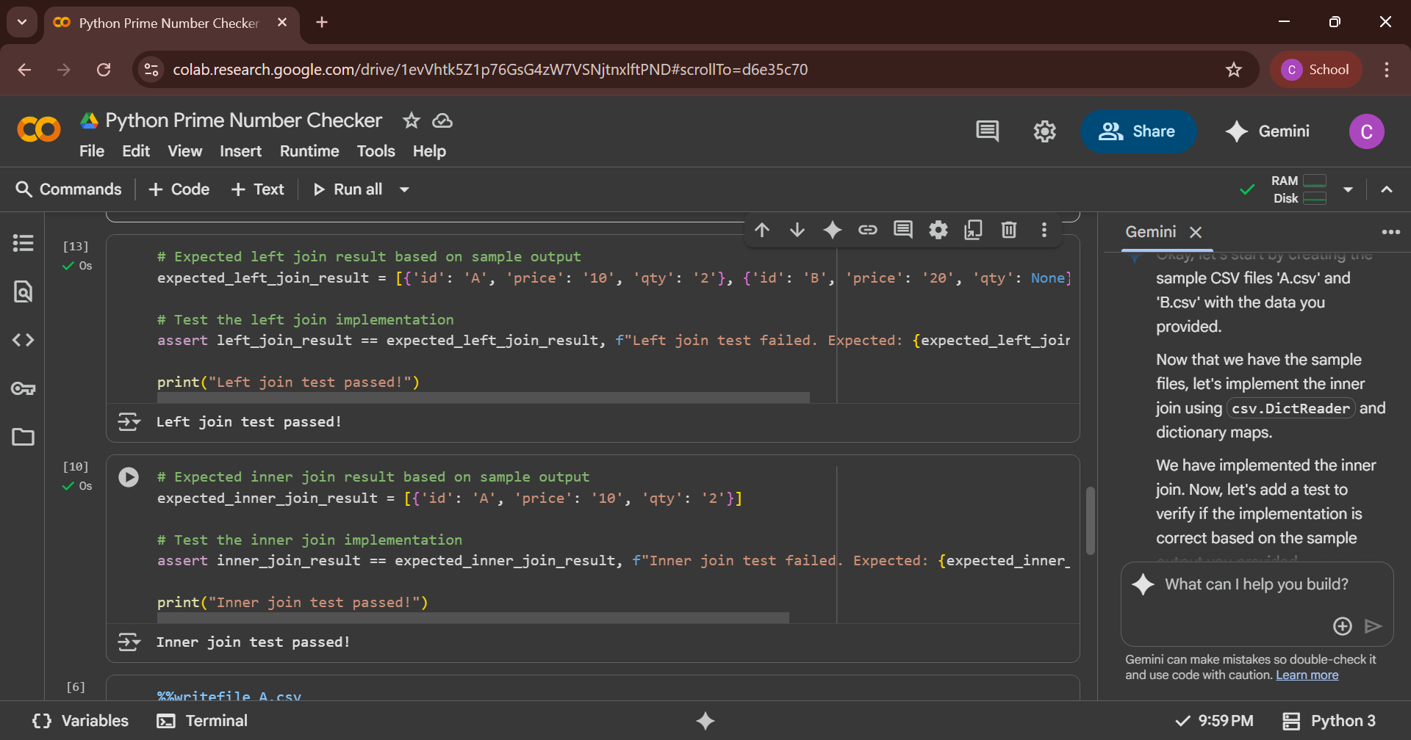
Github link:https://github.com/2403A53057/shwetha.git

